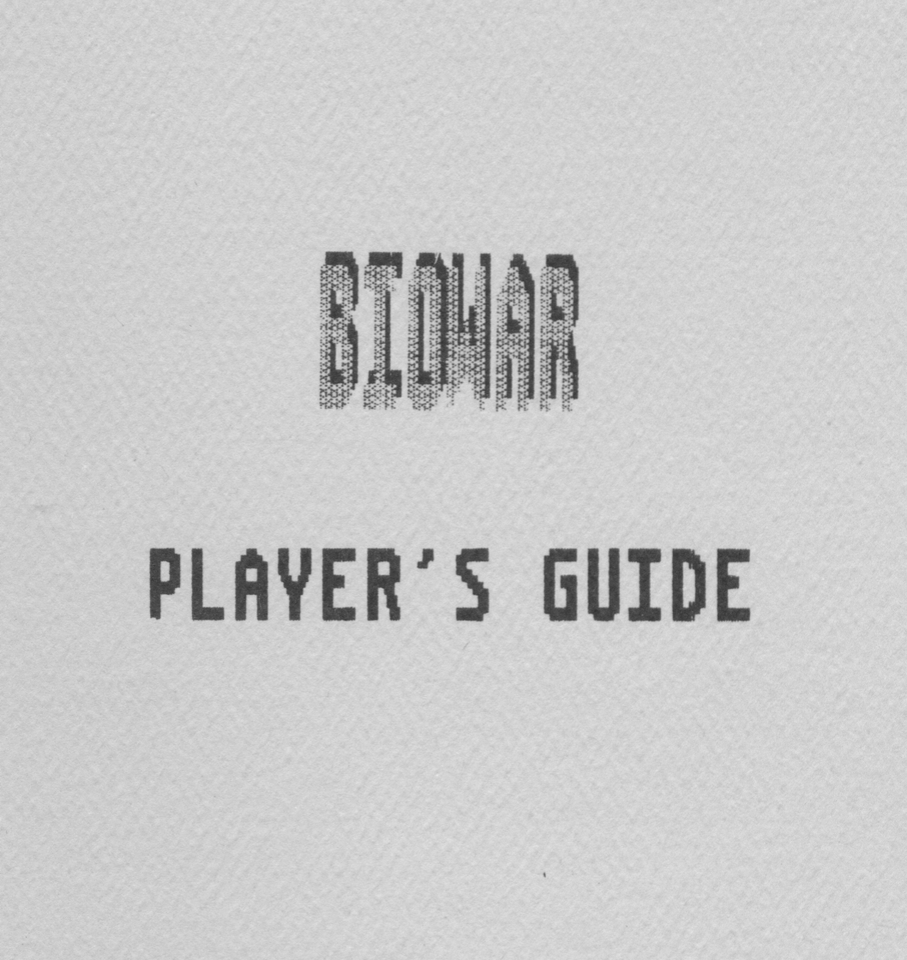

April 15, 1986 BioWar Players Guide

1. Introduction

The three sections of this manual contain all the
information you need to play BioWar. Section 1 introduces
the game; Section 2 gives a brief tour through a sample
game; and Section 3 explains all the rules.

BioWar is an abstract game of cell growth, loosely
based on Conway’s Game of Life which appeared in
Scientific American. Each player attempts to control the
growth of his cells, while trying to kill off all
opposing players’ cells.

BioWar can be played as a multi-player game with up
to 6 players, or a single person can play by himself to
get practice with the growth patterns of the cells.

1-1
April 15, 1986 BioWar Players Guide

1-2
April 15, 1986 BioWar Players Guide

2. Tour

This section gives a quick run through of a sample
one player BioWar session. The tour is written assum-
ing that you are logged into GCP and can follow along
and compare the instructions with what you see on
your screen.

BioWar is located in the Game Floor, just to the
right of Lords Of Space. Make sure that you have your
GAME1 disk in the disk drive, then move your droid
onto the pad in front of BioWar and press the
trigger. The disk will access, then the initial
BioWar screen will appear.

2.1 Screen Layout

The turn number is shown on the top line of the
screen. It will be turn 0 if no one else is playing.
If it is not 0 on your screen, then there are other
people playing. These instructions are for when
there are no other players in BioWar, so what happens
to the cells you place in the upcoming examples will
look different on your screen if there are other
players. Don’t worry about this; just follow along
for now and you will get the basics of how to operate
the game.

When you first enter BioWar, you will not actually be
playing the game; instead you will be in “Spectator
Mode”. This allows you to watch a game in progress if
other people are currently playing.
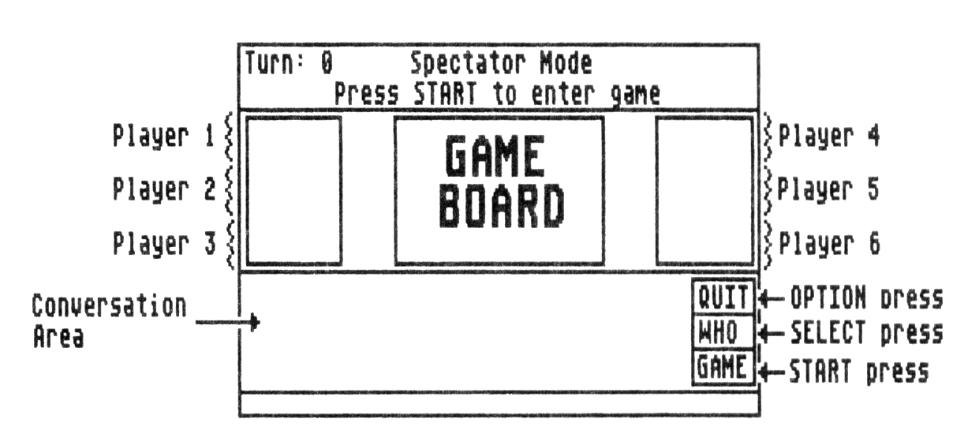
2-2
April 15, 1986 BioWar Players Guide

The central part of the screen shows the game board
and the information about each player. The player
boxes show the cells for each player and the number
of each which are currently on the board. Initially~
there will not be any numbers next to the cells
because the game board is blank.

The blue area below the game board is for conversa-
tions. Type “Hi” and press [Return]. The message will
show up just as if you were in the City.

2.2 Function Key Menu

On the right side of the conversation area is the
Function Key menu. This menu shows the actions for
each of the Function Keys. The top key represents
OPTION, the middle is SELECT and the bottom is START
(they are laid out like the function keys on the
Atari 400/800 and XL computers). Whenever you want to
pick something in the Function Key menu, just press
the appropriate Function Key.

Initially the Function Key Menu will show QUIT, WHO
and GAME. you press OPTION to exit the game. After
you press it, you will be prompted to make sure that
is what you want. Try Pressing it now. The Function
Key menu will change to NO/YES/GAME. Press OPTION
again to select NO (if you pressed SELECT, it would
confirm the QUIT you selected before and exit you
from Biowar).

The Function Key menu will now say QUIT/WHO/GAME
again. Press SELECT to pick WHO. This flips the
conversation area to show the information on the peo-
ple playing the game. It will show their scores and
names. your name will not be shown now, because you
are still a spectator; you have not started playing
yet.

The Function Key menu will now say QUIT/READ/GAME.
Press SELECT again to go back to READing the conver-
sation area.

2.3 Starting the Game

The last choice in the Function Key Menu is GAME. you
can begin the game by pressing START. After a moment,

2-2
April 15, 1986 BioWar Players Guide

the turn number will change to 1 and you will be
placed in the Adjustment Phase. This phase only lasts
for 25 seconds per round, but don’t panic, you can
skip the first few turns.

After the Adjustment Phase is the Growth Phase. This
will update the game board with the new cells based
upon what happened during the Adjustment Phase and
what the board position is.

Now that you are playing the game, pressing SELECT
(to choose WHO in the Function Key menu) will show
your name. There will not be a score next to it
because you must have an opponent to accumulate a
score. Press SELECT again to get back to READing the
conversation area.

To actually start playing, you should wait until the
start of an Adjustment Phase, then move your joystick
around and press the trigger to place cells on the
game board.

For this example, place 5 cells in a horizontal line
in the center of the board, as shown below. You can
then watch the cells change from turn to turn as we
proceed with our tour.

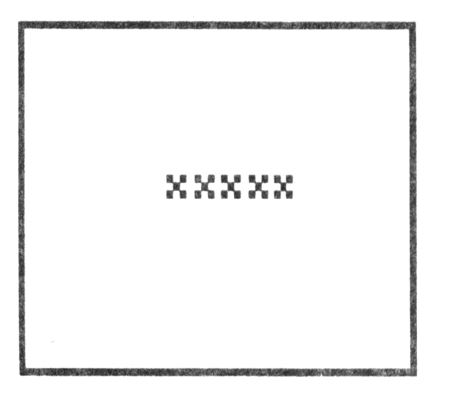
As we mentioned above, each Adjustment Phase lasts 25
seconds. You can shorten it by pressing the START key
(to select DONE in the Function Key Menu). This sig-
nifies that you are done with the Adjustment Phase
and will begin the Growth Phase as soon as all the
other players are finished with their Adjustment. If
there are no other players, the Growth Phase begins
immediately.

2-3
April 15, 1986 BioWar Players Guide

Try pressing START when "Adjustment Phase” is shown
on your screen. You will quickly proceed to the next
turn.

After 6 or 7 turns have passed, your game board will
show one of the following two patterns (unless you
added new cells yourself or started with a different
initial pattern, it will alternate between these
patterns each turn.

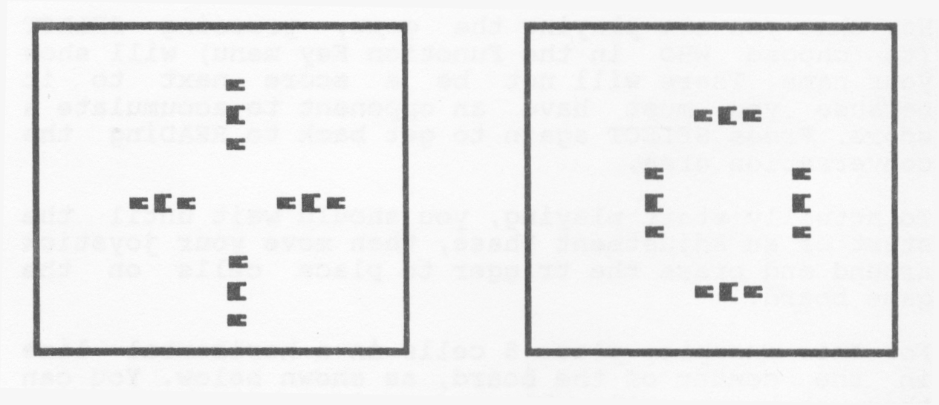

Try adding some new cells with your joystick during
the next Adjustment phase. Keep the cells bunched
together to get a maximum effect. Watch what these
new cells do to the pattern. The rules for how the
cells grow will be explained in the next section. For
now, just observe the effects.

This concludes the initial tour. The section on rules
will explain how players interact, what the different
cells types mean and how 5coring works.

TO leave the game1 press OPTION to QUIT. The Function
Key Menu will change to “NO/YES/DONE". Press SELECT
to pick YES.

2-4
April 15, 1986 BioWar Players Guide

3. Game Rules

Watching the way your cells grew in the Tour might
have given you the impression that what happens to
the cells from one turn to the next is unpredictable.
Actually, the cell growth follows very simple and
straightforward rules. Understanding these rules
helps you predict what your cells will do and how to
effect your opponents’ cells.

3.1 Growth Rules

The growth rules are based upon the 'population' of
cells. The population is measured by counting up the
number of your cells adjacent to each position on the
game board. These adjacent cells are called “neigh-
bors”. (NOTE: adjacency is counted vertically, hor-
izontally and diagonally). The example below shows
the number of neighbors for selected positions on the
board.

The cells of other players count subtract from the
total you get by adding up your cells. The above
example is repeated below, with some enemy cells
added.

In the previous examples, the observant reader may
have noticed a pattern of what the player’s cells
looked like. Each player has 3 markers to represent
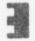
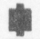
his cells. The largest ( or )marks a cell which

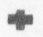
has more than 3 neighbors. The smallest ( or )

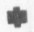
has less than 2 neighbors. The middle size( or )
has either 2 or 3 neighbors.

These 3 different markers directly relate to the cell
growth rules. These rules are listed below.

1. A cell dies off if it has less than 2 neigh-
bors. These cells look like or .

2. A cell dies off if it has more than 3 neigh-
bors. These cells look like or .

3. A new cell is created in any empty position
that has exactly 3 neighbors.

3-1
April 15, 1986 BioWar Players Guide

As you can see, the cell growth rules are quite short
and simple. Being able to accurately predict the
effect of these rules on an entire board in 25
seconds or less is a bit more of a challenge The
following example may help you get started.

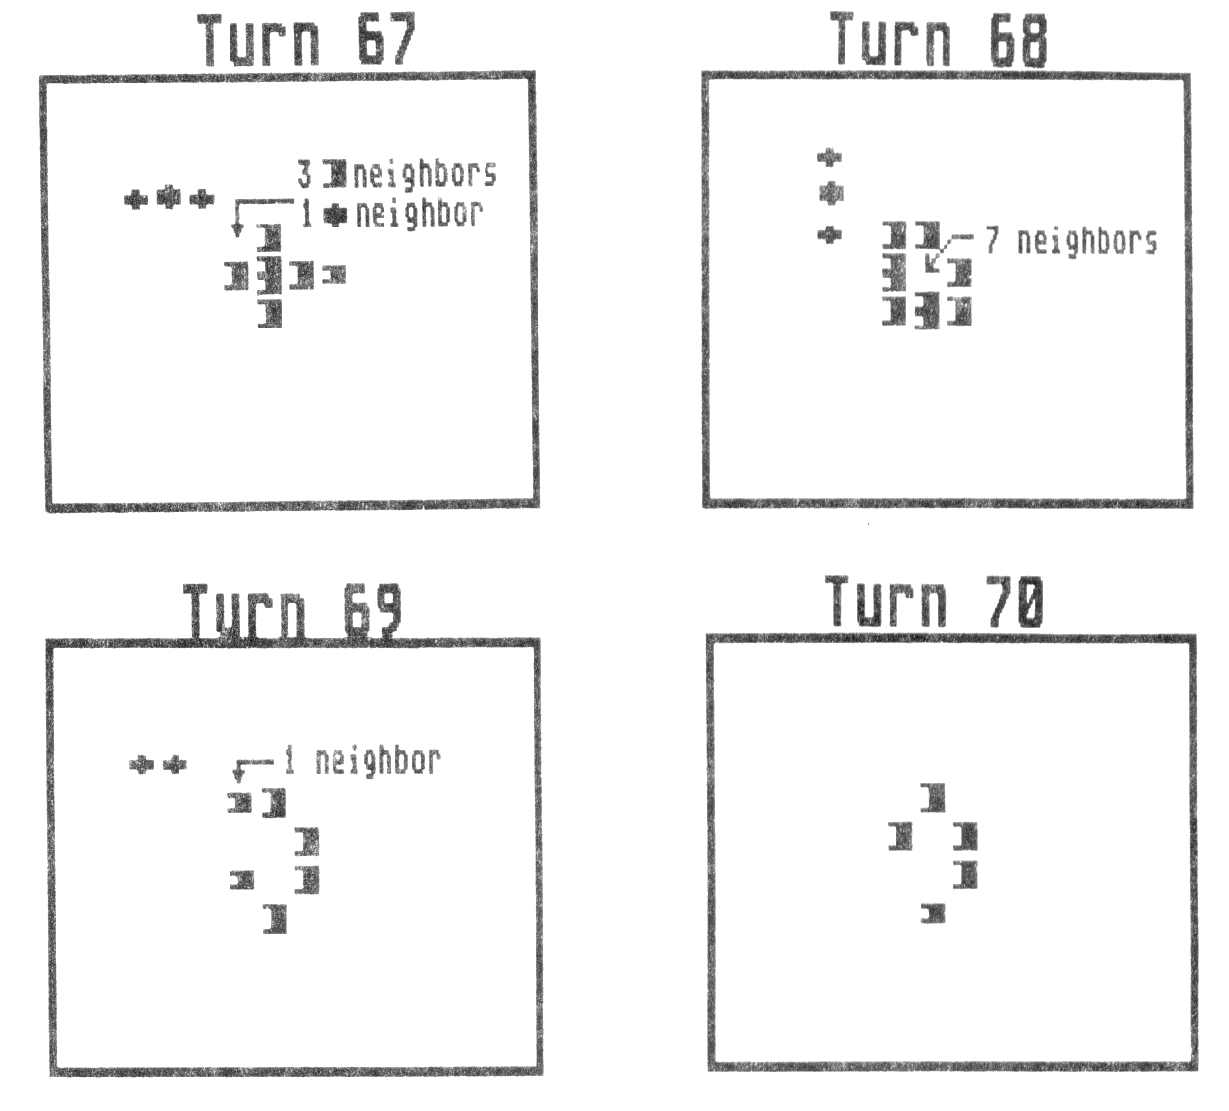
3.2 Placing New Cells

During each Adjustment Phase, you can place new cells
in the empty positions on the board. You place these
new cells by moving the joystick and positioning the
cursor that will appear on an empty position. Then
press the trigger. A will appear on the board to
indicate that you have placed a new cell there.

On the very 1st Adjustment Phase that you place
cells, you can place 10 new cells. On any subsequent
Adjustment Phase you can place a maximum of 5 cells.

If you place a new cells in a position that an

3-2
April 15, 1986 BioWar Players Guide

opponent also places a cell, only one of you will
have a cell placed there.

You can “take back” the placement of a cell by moving
the cursor back onto the position that you put the
new cell and pressing the trigger again. You can only
take back new cells you placed this Phase, and only
before you have used up your allotment of cells for
the Phase.

3.3Ending the Game

You can continue to place new cells on the board as
long as you still have cells on the board. Once all
your cells are gone, you are out of the game. To con-
tinue playing, you must exit back to the Game Floor
and reenter BioWar.

3.4 Scoring

The score that you earn is dependent on how many
cells you have in comparison to your opponents. When
you are playing by yourself, you have no opponents,
and earn no points.

You earn 1 point for each opponent who has fewer
cells on the board than you do for that turn. This
means that in a 6 player game, the person who has the
most cells will earn 5 points for that turn. The
player with the next largest number of cells will
earn 4 points and so on, down to the player with the
fewest cells, who earns no points for that turn.

3-3

